Step 1: Log in to AWS Console
Open the AWS Management Console and sign in.

Step 2: Open EC2 Dashboard
Search for EC2.

Click EC2.

Click Launch Instance.
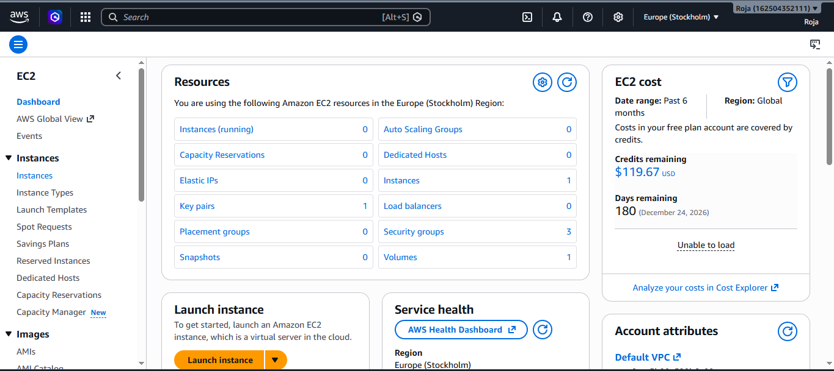

Step 3: Enter Instance Details
- Name: Jenkins-Server
- AMI: Ubuntu Server 24.04 LTS (or 22.04 LTS)
- Instance Type: t2.micro (Free Tier)

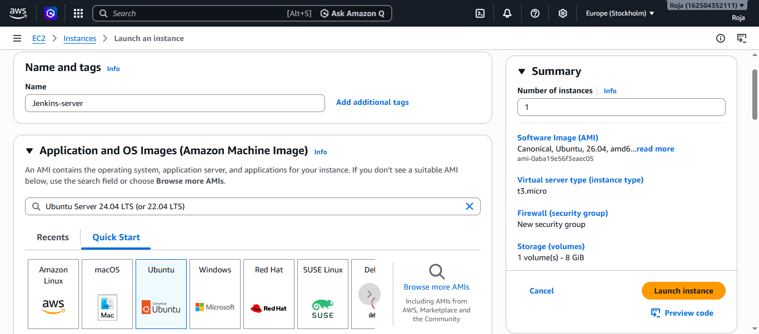

Instance Type: t2.micro (Free Tier)
Create or Select a Key Pair. Download .pem file

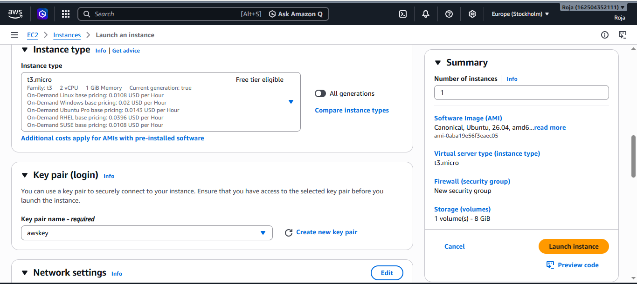
Configure security group
Select allow SSH traffic from – My Ip
Also select Allow HTTPS traffic from the internet and Allow HTTP traffic from the internet
Click on Launch instance
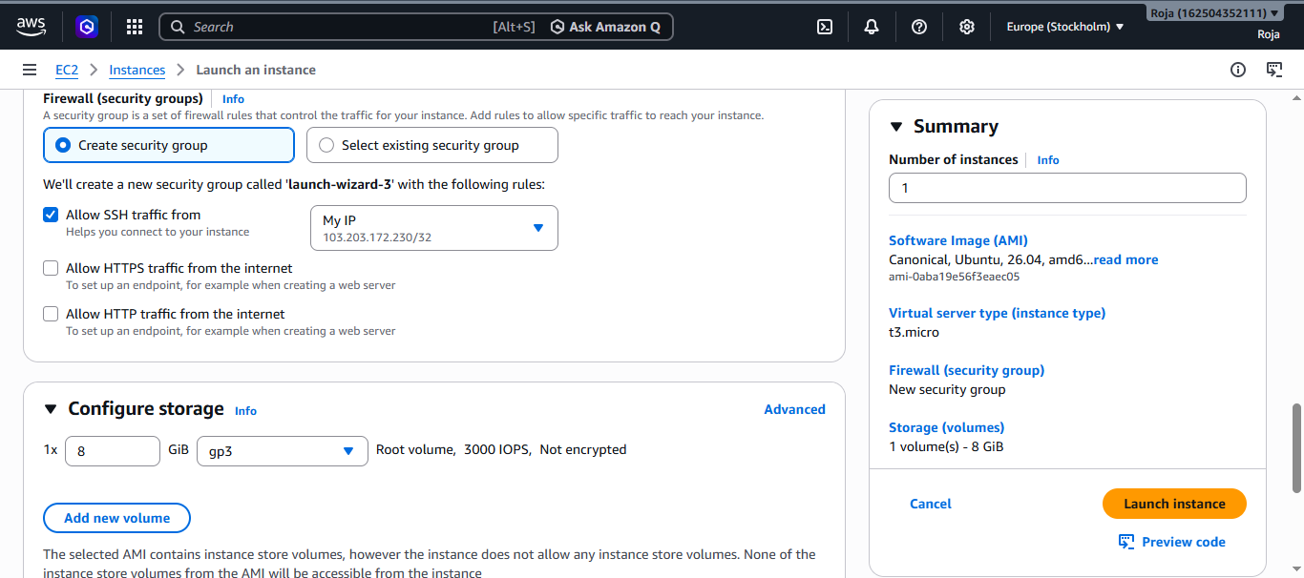

Installed Jenkins

